ECON 311 - Intermediate Macroeconomics (Professor Gordon)
Final Examination: Winter 2022

YOUR NAME: _______________________________________

NetID: _______________________________________

Circle the TA session you attend: Diego – 3PM Gabriel - 3PM
Diego - 4PM Gabriel - 4PM

INSTRUCTIONS:

- The exam lasts 2 hours.
- The exam is worth 120 points in total: 60 points for the multiple choice questions (Part A) and 60 points for the three analytical problems (Part B).
- If you need to change a multiple choice answer, erase the old answer completely.
- Place all of your answers for part B in the spaces provided.
- You must show your work for part B questions. There is no need to explain your answers for the multiple choice questions.

Good luck!

PART A: Multiple Choice Problems
Answer multiple choice questions in the space provided below.
USE CAPITAL LETTERS.
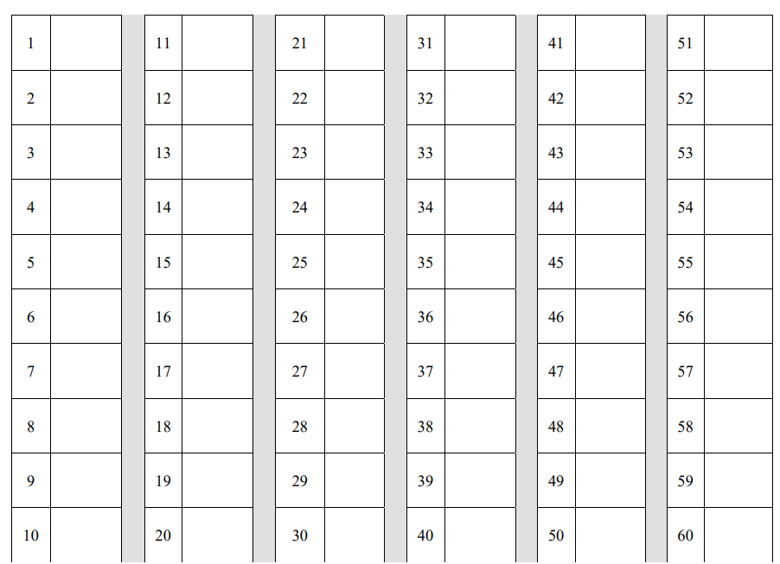
PART A: Multiple choice. Choose the one alternative that best completes the statement or answers the question.

1. If a short-run equilibrium occurs at a level of output above the natural rate, then in the transition to the long run prices will ______, and output will ______.
 | a. | increase; increase
 | b. | decrease; decrease
 | c. | increase; decrease
 | d. | decrease; increase

2. In the Solow growth model the demand for goods equals investment:
 | a. | minus depreciation.
 | b. | plus saving.
 | c. | plus consumption.
 | d. | plus depreciation.

3. If the production function is Y = AK2/3L1/3 in the land of Antegria, and the labor force increases by 5 percent while capital is constant, labor productivity, measured by Y / L, will:
 | a. | increase by 3.33 percent.
 | b. | increase by 1.67 percent.
 | c. | decrease by 1.67 percent.
 | d. | decrease by 3.33 percent.

4. The Solow model shows that a key determinant of the steady-state ratio of capital to labor is the:
 | a. | level of output.
 | b. | labor force.
 | c. | saving rate.
 | d. | capital elasticity in the production function.

5. If the short-run aggregate supply curve is steep, the Phillips curve will be:
 | a. | flat.
 | b. | steep.
 | c. | backward bending.
 | d. | unrelated to the slope of the short-run aggregate supply curve.

6. When an economy begins above the Golden Rule level, reaching the Golden Rule level:
 | a. | results in lower consumption at all times in the future.
 | b. | results in higher consumption at all times in the future.
 | c. | requires initially reducing consumption to increase consumption in the future.
 | d. | requires initially increasing consumption to decrease consumption in the future.

7. Increases in the rate of growth of income per person in the United States in the mid-1990s is mostly likely the result of:
 | a. | increases in human capital.
 | b. | increases in physical capital.
 | c. | advances in information technology.
 | d. | an increase in the saving rate.

8. Other things being equal, all of the following government policies are likely to increase national saving except:
 | a. | decreasing taxes on savings accounts.
 | b. | running a budget deficit.
 | c. | running a budget surplus.
 | d. | retiring part of the national debt.

9. In the Solow growth model, the steady-state growth rate of output per effective worker is ______, and the steady-state growth rate of output per actual worker is ______.
 | a. | the sum of the rate of technological progress plus the rate of population growth; zero
 | b. | zero; the rate of technological progress
 | c. | zero; zero
 | d. | the rate of technological progress; the rate of population growth

10. The short-run Phillips curve:
 | a. | shifts upward if expected inflation increases.
 | b. | shifts upward if expected inflation decreases.
 | c. | shifts downward if expected inflation increases.
 | d. | is vertical.

11. Differences in factor accumulation and/or differences in production efficiency must account for all international differences in:
 | a. | human capital and physical capital.
 | b. | saving rates and population growth rate.
 | c. | income per person.
 | d. | labor efficiency.

12. In the Solow growth model with population growth but no technological change, which of the following will generate a higher steady-state growth rate of total output?
 | a. | a higher saving rate
 | b. | a lower depreciation rate
 | c. | a higher population growth rate
 | d. | a higher capital per worker ratio

13. The short-run aggregate supply curve is drawn for a given:
 | a. | output level.
 | b. | price level.
 | c. | expected price level.
 | d. | level of aggregate demand.

14. We denote by $E_{t}(x)$ the expectation at time t of variable x. Using this notation, the ex post real interest rate at time t equals:
 |  | a. | $$i_{t}- E_{t}(π_{t})$$  ​
 |  | b. | $$i_{t}- E_{t}(π_{t+1})$$  ​
 |  | c. | $$i_{t}- π_{t}$$
 |  | d. | $$i_{t}- π_{t+1}$$  ​

15. Total factor productivity may be measured by:
 | a. | subtracting the rate of growth of capital input and the rate of growth of labor input from the rate of growth of output.
 | b. | subtracting the rate of growth of capital input, multiplied by capital's share of output, plus the rate of growth of labor input, multiplied by labor's share of output, from the rate of growth of output.
 | c. | adding the rate of growth of capital input to the rate of growth of labor input.
 | d. | adding the rate of growth of capital input, multiplied by capital's share of output, to the rate of growth of labor input, multiplied by labor's share of output.

16. Long-run growth in real GDP is determined primarily by ______, while short-run movements in real GDP are associated with ______.
 | a. | variations in labor-market utilization; technological progress
 | b. | technological progress; variations in labor-market utilization
 | c. | money supply growth rates; changes in velocity
 | d. | changes in velocity; money supply growth rates

17. The Phillips curve shows a ______ relationship between inflation and unemployment, and the short-run aggregate supply curve shows a ______ relationship between the price level and output.
 | a. | positive; positive
 | b. | positive; negative
 | c. | negative; negative
 | d. | negative; positive

18. The recent worldwide slowdown in economic growth began in the early:
 | a. | 1960s.
 | b. | 1970s.
 | c. | 1980s.
 | d. | 1990s.

19. If the short-run aggregate supply curve is horizontal, then changes in aggregate demand affect:
 | a. | level of output but not prices.
 | b. | prices but not level of output.
 | c. | both prices and level of output.
 | d. | neither prices nor level of output.

20. Each of the two models of short-run aggregate supply is based on some market imperfection. In the sticky-price model, the imperfection is that:
 | a. | some firms do not adjust their prices instantly to changes in demand.
 | b. | expectations are formed adaptively rather than rationally.
 | c. | firms confuse changes in the overall level of prices with changes in relative prices.
 | d. | the real wage adjusts to bring labor supply and labor demand into equilibrium.

21. If two economies are identical (with the same population growth rates and rates of technological progress), but one economy has a lower saving rate, then the steady-state level of income per worker in the economy with the lower saving rate:
 | a. | will be at a lower level than in the steady state of the high-saving economy.
 | b. | will be at a higher level than in the steady state of the high-saving economy.
 | c. | will be at the same level as in the steady state of the high-saving economy.
 | d. | will grow at a slower rate than in the high-saving economy.

22. Which of the following changes would bring the U.S. capital stock, currently below the Golden Rule level, closer to the steady-state, consumption-maximizing level?
 | a. | increasing the population growth rate
 | b. | increasing the rate of capital depreciation
 | c. | increasing the rate of technological progress
 | d. | increasing the saving rate

23. In the Solow model with technological progress, the steady-state growth rate of output per effective worker is:
 | a. | 0.
 | b. | g.
 | c. | n.
 | d. | n + g.

24. The government-purchases multiplier indicates how much ______ change(s) in response to a $1 change in government purchases.
 | a. | the budget deficit
 | b. | consumption
 | c. | income
 | d. | real balances

25. Exhibit: Saving, Investment, and the Interest Rate 1
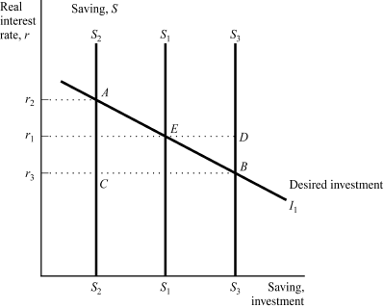
The economy begins in equilibrium at point E, representing the real interest rate r1 at which saving S1 equals desired investment I1. What will be the new equilibrium combination of real interest rate, saving, and investment if the government cuts taxes, holding other factors constant?
 | a. | point A
 | b. | point B
 | c. | point C
 | d. | point D

26. Exhibit: IS*–LM*
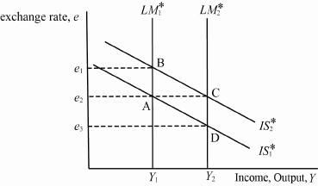
A small open economy with a floating exchange rate is initially at equilibrium A with equilibrium exchange rate e2, and equilibrium output Y1. If there is a monetary expansion to the new equilibrium will be at ____, holding everything else constant.
 | a. | A
 | b. | B
 | c. | C
 | d. | D

27. The market value of all final goods and services produced within an economy in a given period of time is called:
 | a. | industrial production.
 | b. | gross domestic product.
 | c. | the GDP deflator.
 | d. | general durable purchases.

28. If there is a fixed-exchange-rate system, then in the long run:
 | a. | the nominal exchange rate is fixed, but the real exchange rate is free to vary.
 | b. | the real exchange rate is fixed, but the nominal exchange rate is free to vary.
 | c. | both the nominal and real exchange rates are fixed.
 | d. | the nominal and real exchange rates vary by a fixed amount.

29. If the consumption function is given by C = 150 + 0.85(Y – T) and T increases by 1 unit, then saving
 | a. | decreases by 0.85 units.
 | b. | decreases by 0.15 units.
 | c. | increases by 0.15 units.
 | d. | increases by 0.85 units.

30. The theory of liquidity preference states that, other things being equal, an increase in the real money supply will:
 | a. | lower the interest rate.
 | b. | raise the interest rate.
 | c. | have no effect on the interest rate.
 | d. | first lower and then raise the interest rate.

31. Exhibit: IS–LM Monetary Policy
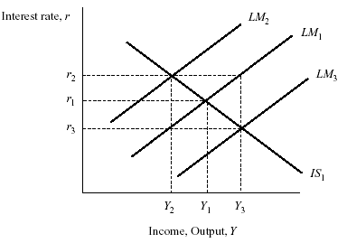
Based on the graph, starting from equilibrium at interest rate r1 and income Y1, a decrease in the money supply would generate the new equilibrium combination of interest rate and income:
 | a. | r2, Y2
 | b. | r3, Y2
 | c. | r2, Y3
 | d. | r3, Y3

32. In the Mundell–Fleming model, if the economy is operating at or below the natural level in the short run, then in the long run the price level will fall, the exchange rate will ______, and net exports will ______ to restore the economy to its natural rate.
 | a. | appreciate; increase
 | b. | appreciate; decrease
 | c. | depreciate; increase
 | d. | depreciate; decrease

33. Under a floating system, the exchange rate:
 | a. | fluctuates in response to changing economic conditions.
 | b. | is maintained at a predetermined level by the central bank.
 | c. | is changed at regular intervals by the central bank.
 | d. | fluctuates in response to changes in the price of gold.

34. An example of a nominal variable is the:
 | a. | money supply.
 | b. | quantity of goods produced in a year.
 | c. | relative price of bread.
 | d. | real wage.

35. The marginal propensity to consume is:
 | a. | expected to be between zero and one.
 | b. | equal to disposable income divided by consumption.
 | c. | the amount by which consumption changes when wealth increases by one dollar.
 | d. | normally assumed to increase as taxes increase.

36. Assume that a tire company sells four tires to an automobile company for $400, another company sells a compact disc player for $500, and the automobile company puts all of these items in or on a car that it sells for $20,000. In this case, the amount from these transactions that should be counted in GDP is:
 | a. | $20,000.
 | b. | $20,000 less the automobile company's profit on the car.
 | c. | $20,900.
 | d. | $20,900 less the profits of all three companies on the items that they sold.

37. In a small open economy, if consumers shift their preference toward Japanese cars, then net exports:
 | a. | fall, and the real exchange rate falls.
 | b. | fall, but the real exchange rate remains unchanged.
 | c. | remain unchanged, but the real exchange rate falls.
 | d. | increase, and the real exchange rate remains unchanged.

38. Exhibit: Saving, Investment, and the Interest Rate 2
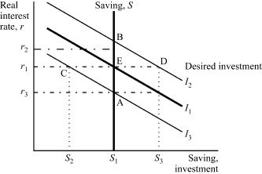
The economy begins in equilibrium at point E, representing the real interest rate r1 at which saving S1 equals desired investment I1. What will be the new equilibrium combination of real interest rate, saving, and investment if there is a tax law change that makes investment projects less profitable and decreases the demand for investment goods (but does not change the amount of taxes collected in the economy)?
 | a. | point A
 | b. | point B
 | c. | point C
 | d. | point D

39. In principle, the GDP accounts should—but do not—have an imputation for:
 | a. | housing services enjoyed by homeowners.
 | b. | rental services of automobiles driven by owners.
 | c. | meals cooked in restaurants.
 | d. | housing services enjoyed by renters.

40. The central bank in the United States is the:
 | a. | Bank of America.
 | b. | U.S. Treasury.
 | c. | U.S. National Bank.
 | d. | Federal Reserve.

41. All of the following are considered major functions of money except as a:
 | a. | medium of exchange.
 | b. | way to display wealth.
 | c. | unit of account.
 | d. | store of value.

42. During the Great Depression, countries that devalued their currencies generally ______, whereas countries that maintained the old exchange rate ______.
 | a. | suffered longer; experienced no depression
 | b. | recovered relatively quickly; experienced no depression
 | c. | suffered longer; recovered relatively quickly
 | d. | recovered relatively quickly; suffered longer

43. In the United States, bank reserves consist of:
 | a. | currency and demand deposits.
 | b. | vault cash and deposits at the Federal Reserve.
 | c. | gold deposits at the Federal Reserve.
 | d. | the money supply.

44. In a small open economy with a floating exchange rate, if the government increases the money supply, then in the new short-run equilibrium, the:
 | a. | interest rate falls and the level of investment rises.
 | b. | exchange rate falls and net exports increase.
 | c. | interest rate falls but the level of investment does not rise.
 | d. | exchange rate falls but net exports do not increase.

45. Assume that the consumption function is given by C = 200 + 0.7(Y – T), the tax function is given by T = 100 + 0.2Y, and Y = 50K0.5L0.5, where K = 100. If L increases from 100 to 144, then consumption increases by:
 | a. | 560.
 | b. | 840.
 | c. | 1,120.
 | d. | 2,120.
46. From the reading on the convergence diagram, choose which statement is correct: On average:
 | a. | countries converged, people converged
 | b. | countries did not converge, people did not converge
 | c. | countries did not converge, people converged
 | d. | countries converged, people did not converge

47. Which of the following by 2018 had converged closest to the U.S. level of real income per person?:
 | a. | Emerging Europe
 | b. | Emerging Asia

 | c. | Latin America
 | d. | Sub-Saharan Africa

48. The “Rio Grande puzzle” occurs because new immigrants to the U.S. have the same ________ as they did when they departed from their country of origin
 | a. | physical capital
 | b. | human capital
 | c. | infrastructure capital.
 | d. | political capital

49. According to research cited by the textbook, colonies in temperate zones had _____________ institutions whereas countries in tropical zones had ______________ institutions.
 | a. | inclusive; exclusive.
 | b. | exclusive; inclusive
 | c. | inclusive; extractive.
 | d. | extractive; inclusive

50. Which of the following countries did not place emphasis on curing illiteracy as part of its development process?
 | a. | South Korea
 | b. | India
 | c. | Japan
 | d. | China

51. Which of the following countries had the fastest growth rate of per-person real income from 1870 until now?
 | a. | United States
 | b. | United Kingdom
 | c. | Germany
 | d. | Japan

52. A lecture described the Sears catalog as being the “old-technology” version of Amazon. Where were the catalogs and ordered merchandise mailed from?
 | a. | Chicago
 | b. | New York
 | c. | Cleveland
 | d. | St. Louis

53. An article explained the rapid growth of the emerging economies from 2000 to 2010 as resulting from all of the following except:
 | a. | openness to trade.
 | b. | low inflation.
 | c. | low commodity prices.
 | d. | low interest rates.

54. In comparison with U.S. states, the Euro area has these two disadvantages:
 | a. | language barriers and lack of central fiscal authority
 | b. | lack of central fiscal authority and lack of a central bank.
 | c. | lack of a central bank and language barriers
 | d. | language barriers and barriers to travel and trade

55. The article on Trump’s China tariffs made all these points except:
 | a. | raising tariffs raises the exchange rate and cuts exports.
 | b. | Americans buy imports because they are cheaper or make us better.
 | c. | many imports are intermediate goods needed in U.S. manufacturing.
 | d. | declining imports aggravated shortages in the U.S. economy in 2020-21.

56. A peak in the U.S. inflation rate did not occur in which of these years?
 | a. | 1974-75
 | b. | 1980-81
 | c. | 1998-99
 | d. | 2021

57. The sacrifice ratio for the Volcker disinflation was:
 | a. | 1
 | b. | 3
 | c. | 6
 | d. | 9

58. The time interval 2000-2005 was notable because::
 | a. | the dollar appreciated and net exports rose.
 | b. | the dollar appreciated and net exports fell.
 | c. | the dollar depreciated and net exports rose.
 | d. | the dollar depreciated and net exports fell..

59. Which of the following was not a cause of the Mexican financial crisis of 1994?
 | a. | political unrest
 | b. | decline in foreign investment
 | c. | higher U.S. interest rates
 | d. | inadequate dollar reserves

60. One recession had by far the greatest incidence of long-term (>6 months) unemployment. Which one?
 | a. | 1973-75.
 | b. | 1981-82.
 | c. | 1990-91.
 | d. | 2007-09.

ANSWERS

1. c

2. c

3. d

4. c

5. b

6. b

7. c

8. b

9. b

10. a

11. c

12. c

13. c

14. d

15. b

16. b

17. d

18. b

19. a

20. a

21. a

22. d

23. a
24. c

25. a

26. d

27. b

28. a

29. b

30. a

31. a

32. c

33. a

34. a

35. a

36. a

37. c

38. a

39. b

40. d

41. b

42. d

43. b

44. b

45. a

46. c

47. a

48. b

49. c

50. b

51. d

52. a

53. c

54. a

55. a

56. c

57. b

58. d

59. b

60. d

PART B: Analytic Problems.

QUESTION 1 (12 points)

Consider two countries: Poorland and Richland (which we will call P and R, respectively). Both countries have the same Cobb Douglas function, given by $Y=K^{0.5}L^{0.5}$.

- Suppose that the real GDP per person in R is 4 times that of P. What is the ratio of capital per capita of country R to the capital per capita of country P? (Normalize real GDP per person of country P to 1) (Define per capita variables as Y/L = y and K/L = k) (3 points)
y = k0.5 which implies k = y2.
If poor country has a real GDP of 1 and rich country is 4 times bigger, then k=1 for poor country and k=16 for rich country. The ratio is 16/1 = 16.
- Find the ratio of the marginal product of capital of R to the marginal product of capital of P. (3 points)
MPK = 0.5 k-0.5. For poor country this is 0.5. For rich country this is 0.5/4. The ratio equals 0.25.
- Suppose that the population growth rate is 0.02 and the depreciation rate $δ$ is 0.01 in both countries. Assume that in P the savings rate is 0.15 and in R it is 0.3. Find the steady state values of capital per capita in both countries. (Note: the ratio of R to P in your answer will be different in part c than in part a. This is because part a is not a steady state). (3 points) (4 points)
Starting from s*k0.5 = (n+δ)k
Formula is $k= {\left(\frac{s}{n+δ}\right)}^{1/0.5}$. Poor Country: $k= {\left(\frac{0.15}{0.02+0.01}\right)}^{2}=5^{2}=25$
Rich Country: $k= {\left(\frac{0.3}{0.02+0.01}\right)}^{2}={10}^{2}=100$
- Using the information in c), find the steady state values of output per capita in both countries. (2 points)
Using y = k0.5, we know that for the poor country y equal 5 and for the rich country y equals 10.

QUESTION 2 (12 points)

A small open economy with perfect capital mobility and a flexible exchange rate regime is characterized by the following set of equations.
$$Y=C+I+G+NX \\ G=2000 \\ T=2000 \\ C=500+0.5\left(Y-T\right) \\ I=1000-50 r \\ NX=1500-250ϵ \\ {\left(M/P\right)}^{d}=0.2Y-10r \\ {\left(M/P\right)}^{s}=900$$
- Assume that foreign and domestic interest rates are equal and initially let the foreign exchange rate be equal to 4. Find the IS and LM equations. (2 points)
IS: Y = 6000 – 100r (or Y = 8000 – 100r -500e)
LM: Y = 4500 + 50r (or 900 = 0.2Y – 10r)
- Find the equilibrium income, interest rate and net exports. (2 points)
Y = 5000; r = 10; NX = 500
- Suppose government expenditure goes up from 2000 to 3000. Write down the new IS curve (solving for Y) taking into account that there is a flexible exchange rate regime. (2 points)
Y = 10,000 – 100r – 500e
- Calculate the new output and exchange rate (Hint: changes in a small open economy do not change the world interest rate). (3 points)
From LM we know Y stays fixed if r stays fixed too: Y = 5000.
From IS we solve for the new e: 5000 = 10,000 – 100(10) – 500e
=> e = 8
- Ignoring the increase in government expenditure (ie ignoring your results from parts c and d), assume real money supply goes up from 900 to 1000. Calculate the new output and exchange rate (Hint: changes in a small open economy do not change the world interest rate). (3 points)
Using LM and fixed r: 1000 = 0.2Y – 10(10) => Y = 5500
From original IS: 5500 = 8000 – 100(10) – 500e => 1500 = 500e => e = 3

QUESTION 3 (12 points)

The following table summarizes real GDP and real GDP growth rate for two countries, A and B, in 2021:
 | Real GDP (2021) | Real GDP annual growth rate (2021)
Country A | 2000 | 4%
Country B | 2500 | 3%

- If both counties continue to grow at the same rate, which country will first reach a GDP level of at least 5000? (3 points)
A needs to grow 2.5 times: ln2.5 / 0.04 = 22.09 years
B needs to grow 2 times: ln2 / 0.03 = 23.10 years
A reaches the level first.
- Assume that nominal GDP in country A in 2021, using 2015 as base year, was 3200. Using GDP Deflator, what was the average annual inflation rate between 2015 and 2021 in Country A? (3 points)
GDP deflator is 3200/2000 = 1.6
Inflation rate between 2015 and 2021, annualized: ln(1.6/1)/6 = 7.83%
- Assume that the economy of country B will grow at an annual rate of 3% starting from year 2021 onwards. How long will it take for country B to reach a nominal GDP of 3000? (3 points)
Years = 100*ln(3000/2500)/3 = 6.07 years
- Assume that real GDP of country A will grow at an annual rate of 5% starting from year 2022 onwards (Country B stays at 3%).In how many years will their real GDPs be equal? (3 points)
.05s + ln(2000) = .03s + ln(2500) => .02s = ln(25/20) => s = 11.16 years

QUESTION 4 (12 points)

Suppose the production function of a closed economy is given by $Y=L^{1/4}K^{3/4}$, where K is capital, and L is labor. Assume there is only consumption and savings (no taxes or government spending).
Suppose that capital depreciates at $δ=0.01$, the savings rate is s = 0.4, and population growth is n = 0.04. ) (Define per capita variables as Y/L = y and K/L = k)

- Find the steady state level of capital per capita (2 points)
y = k3/4 => 0.4 * k3/4 = (n + d)k => k = (s/(n+d))4
k = (0.4/(0.01+0.04))4 = (8)4 = 4096
- Find the steady state level of output per capita and consumption per capita (2 points)
y = (4096)3/4 = 512
c = (1-s)y = 0.6 * 512 = 307.2
- Assume the savings rate goes down to 0.2. Solve for the steady state consumption per capita. Does it go up or down compared to your result in part b? (3 points)
New k = (0.2/(0.01+0.04))4 = (4)4 = 256
New y = (256)3/4 = 64
New c = 0.8 * 64 = 51.2 (Goes down)
- What is the golden rule steady state level of capital per capita? (3 points)
MPK = delta + n => MPK = 0.75k-1/4 = 0.01 + 0.04 = 0.05
0.75/0.05 = 15 = k1/4 => k = 50,625
- What is the implied savings rate from part d? (2 points)
$$\frac{k^{*}}{f\left(k^{*}\right)}=\frac{s}{δ+n} \\ \frac{50625}{3,375}=\frac{s}{0.01+0.04} \\ 15*0.05=s \\ s=0.75$$

QUESTION 5 (12 points)

An economy has the following equation for the Phillips curve:$π=Eπ-0.25(u-8)+ ν$
People form expectations of inflation by looking at last year’s inflation: $Eπ=π_{-1}$
Okun’s law for this economy is: $\frac{Y-Y_{-1}}{Y_{-1}}=3-2(u-u_{-1})$
The economy begins at its natural rate of unemployment with a stable inflation rate of 10 percent.
- Assume that the economy has been at the natural rate of unemployment and at stable inflation rate of 10 percent for several periods. What is the growth rate of real GDP? What is the growth rate of nominal GDP? (6 points)
Real: Using Okun’s law: $\frac{Y-Y_{-1}}{Y_{-1}}=3-2\left(u-u_{-1}\right)=3-2\left(8-8\right)= 3$
Nominal: 3 + 10 = 13
- The following period arrives. A supply shock affects the economy, making $ν=9$. If nominal GDP growth did not change, what were the levels of unemployment and inflation in this period? (6 points)
Build system of two equations – two unknowns (Note Real growth = nominal – pi)
(1) Using Okun’s law: $\frac{Y-Y_{-1}}{Y_{-1}}=13-π=3-2\left(u-8\right)$
or: $π-2u=-6$
(2) Using Phillips curve with shock: $π=10-0.25\left(u-8\right)+ 9$
or $π+0.25 u=10+2+9=21$
So $π=18;u=12$

